**NONFICITON** Summer Reading Assignment **NONFICITON** Summer Reading Assignment

**NONFICTION REVIEW POST-ITS**

* You will be reviewing your book to find evidence/ examples that support the prompt you select from the choices below. Find **FOUR** pieces of textual evidence that help to illustrate the prompt you have chosen. Mark each piece of evidence with a post it, and do the following:
* Put the book’s page number on the post it
* Label the post it according to the prompt (FACTS/STATS, OPINION, TEXT FEATURES, or PURPOSE)
* Explain (on the post it) in 3-4 ***full sentences*** how/why the evidence is significant in addressing the prompt.

**NONFICTION PROMPTS**

Choose to answer ONE of the following questions. Put a check mark in the box next to the ONE question you will respond to.

* Choose two significant **FACTS/STATS/DETAILS** that are used in the text and explain their importance and impact to the text.
* Choose one significant instance of the **AUTHOR EXPRESSING HIS/HER OPINION** about the topic of the text, describe the opinion and explain its importance and impact to the text.
* Address the significance of **TEXT FEATURES** to the novel. Give examples of text features and specifically what they accomplish
* What’s the **PURPOSE** of the novel? Identify examples/evidence that help reveal why the author wrote it.

**NONFICTION REVIEW POST-ITS**

* You will be reviewing your book to find evidence/ examples that support the prompt you select from the choices below. Find **FOUR** pieces of textual evidence that help to illustrate the prompt you have chosen. Mark each piece of evidence with a post it, and do the following:
* Put the book’s page number on the post it
* Label the post it according to the prompt (FACTS/STATS, OPINION, TEXT FEATURES, or PURPOSE)
* Explain (on the post it) in 3-4 ***full sentences*** how/why the evidence is significant in addressing the prompt.

**NONFICTION PROMPTS**

Choose to answer ONE of the following questions. Put a check mark in the box next to the ONE question you will respond to.

* Choose two significant **FACTS/STATS/DETAILS** that are used in the text and explain their importance and impact to the text.
* Choose one significant instance of the **AUTHOR EXPRESSING HIS/HER OPINION** about the topic of the text, describe the opinion and explain its importance and impact to the text.
* Address the significance of **TEXT FEATURES** to the novel. Give examples of text features and specifically what they accomplish
* What’s the **PURPOSE** of the novel? Identify examples/evidence that help reveal why the author wrote it.

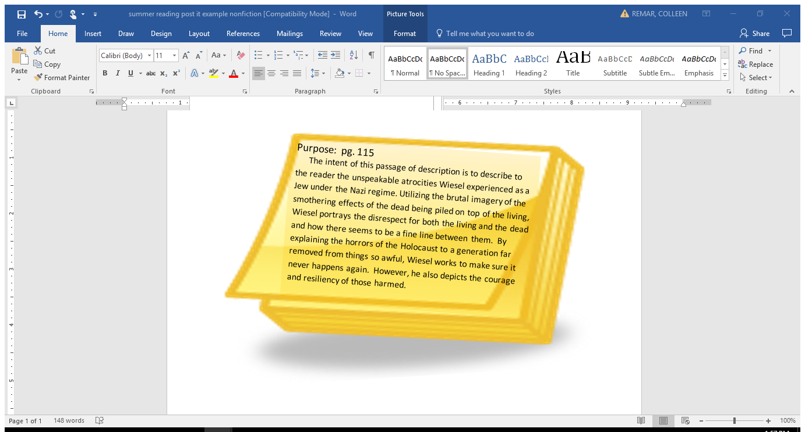

**SAMPLE POST IT**

**SAMPLE POST IT**